**Germancredit dataset**:

**1.** **List the attribute names and its types**:

|  |  |
| --- | --- |
| Attribute name | type |
| checking status | Nominal |
| duration | Numeric |
| credit history | Nominal |
| purpose | Nominal |
| credit amount | Numeric |
| savings status | Nominal |
| employment | Nominal |
| installment commitment | Numeric |
| personal status | Nominal |
| other parties | Nominal |
| residence since | Numeric |
| property magnitude | Nominal |
| age | Numeric |
| other payment plans | Nominal |
| housing | Nominal |
| existing credits | Numeric |
| job | Nominal |
| num dependents | Numeric |
| own telephone | Nominal |
| foreign worker | Nominal |
| class | Nominal |

**2. No of records in each dataset**: 1000(instances)

**3. Identify the class attribute:**

Class- Nominal

4.HISTOGRAMS: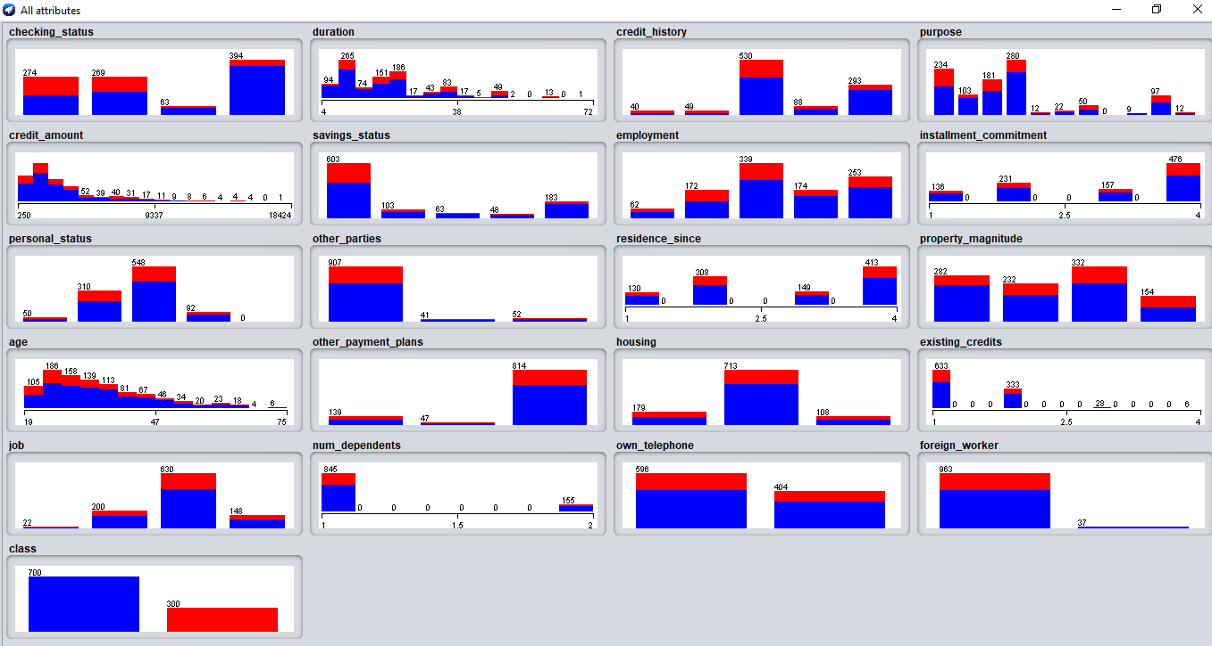

**5.Determine the number of records in each class**:

Number of records for class:

* Good - 700
* Bad - 300